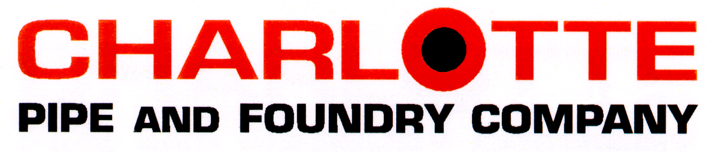

Edge HP Iron Hub and Spigot Specification

A. Pipe and Fittings: ASTM A74, Service class.
B. Tensile Strength: 21,000 psig minimum.
C. All pipe and fittings shall be marked with the collective trademark of the Cast Iron Soil Pipe Institute® and listed by NSF® International.
D. Each length of pipe and each fitting shall be plainly marked with size, country of origin, and name of manufacturer, or manufacturer’s registered trademark by which the manufacturer can be readily identified after installation.
E. The inside of each pipe shall be reamed prior to coating to decrease the coefficient of friction.
F. Gaskets: ASTM C564 rubber.
G. Caulking Materials: ASTM B29, pure lead and oakum or hemp fiber.
H. Pipe Coating: Chemically deposited zinc-phosphate pretreatment layer followed by an electrically deposited, high-performance cathodic epoxy coating, and finally an electrically deposited, high-performance anodic epoxy top coat.
I. Fitting Coating: Chemically deposited zinc-phosphate pretreatment layer followed by an electrically deposited, high-performance cathodic epoxy coating, and finally an epoxy acrylic powder top coat.
J. Coating Performance: Pipe and Fitting Coatings must pass the following performance specifications per EN 877:
a. 350 hours of salt spray testing
b. Resistance to wastewater for 30 days at 73° F
c. Chemical resistance from pH 2 to pH 12 for 30 days at 73° F
d. Resistance to hot water for 24 hours at 203° F

