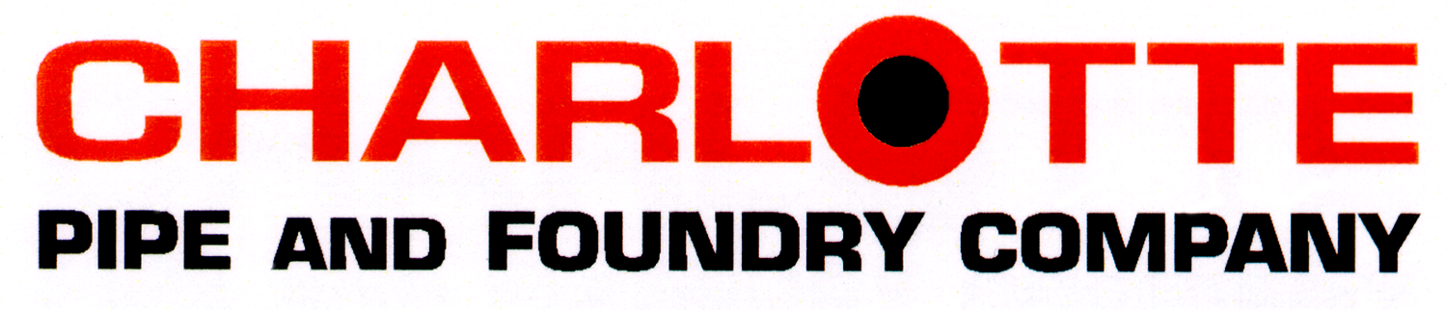

Cast Iron Soil Pipe Suggested Short Form Specification

Hubless Cast Iron Soil Pipe and Fittings:

Hubless Cast Iron pipe and fittings shall be manufactured from gray cast iron and shall conform to ASTM A 888 and CISPI Standard 301. All pipe and fittings shall be marked with the collective trademark of the Cast Iron Soil Pipe Institute ® and listed by NSF® International. Hubless Couplings shall conform to CISPI Standard 310, shall be manufactured in the United States, and be certified by NSF® International. Heavy Duty couplings shall conform to ASTM C 1540, shall be manufactured in the United States, and shall be used if indicated. Gaskets shall conform to ASTM C 564. All pipe and fittings to be produced by a single manufacturer and are to be installed in accordance with manufacturer’s recommendations and applicable code requirements. Couplings shall be installed in accordance with the manufacturer’s band tightening sequence and torque recommendations. Tighten bands with a properly calibrated torque limiting device. The system shall be hydrostatically tested after installation to 10 ft. of head (4.3 psi maximum). WARNING! Never test with or transport/store compressed air or gas in Cast Iron pipe or fittings. Doing so can result in explosive failures and cause severe injury or death.

Hub and Spigot Cast Iron Soil Pipe and Fittings:

Hub and Spigot Cast Iron pipe and fittings shall be manufactured from gray cast iron and shall conform to ASTM A 74. All pipe and fittings shall be marked with the collective trademark of the Cast Iron Soil Pipe Institute ® and listed by NSF® International.
Pipe and fittings to be [pick one or both]:
□ Service (SV) or
□ Extra Heavy (XH)
Joints can be made using a compression gasket manufactured from an elastomer meeting the requirements of ASTM C 564 or lead and oakum. All pipe and fittings to be produced by a single manufacturer and are to be installed in accordance with manufacturer’s recommendations and applicable code requirements. The system shall be hydrostatically tested after installation to 10 ft. of head (4.3 psi maximum). WARNING! Never test with or transport/store compressed air or gas in Cast Iron pipe or fittings. Doing so can result in explosive failures and cause severe injury or death.

SPEC-SF-CI (316)

